

Delightful Derbyshire Dales
meet the groups event February 2024

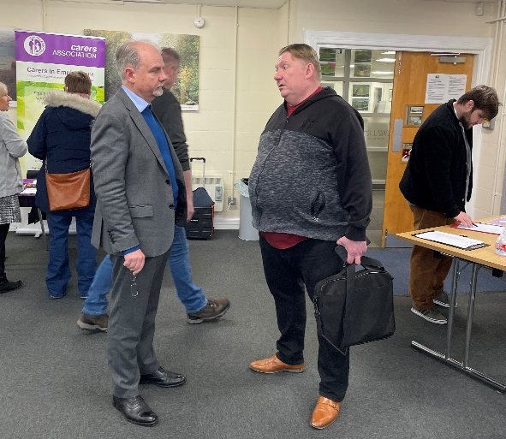
10 tables were hosted by local mental health and wellness groups, activity coordinators, service providers and individual’s across Derbyshire Dales, promoting some of what is on offer locally.

Many of those attending the event reported that due to their roles they were already aware of the groups being promoted but, they also reported that they appreciated the opportunity of face to face conversations about partner opportunities.

Yet over 148 made NEW connections J and 14 of those people made more than 5 NEW connections today!

No. of connections: | 1 | 2 | 3 | 4 | 5 | 5+
How many people made this many connections: |  | 3 | 5 | 4 | 3 | 14
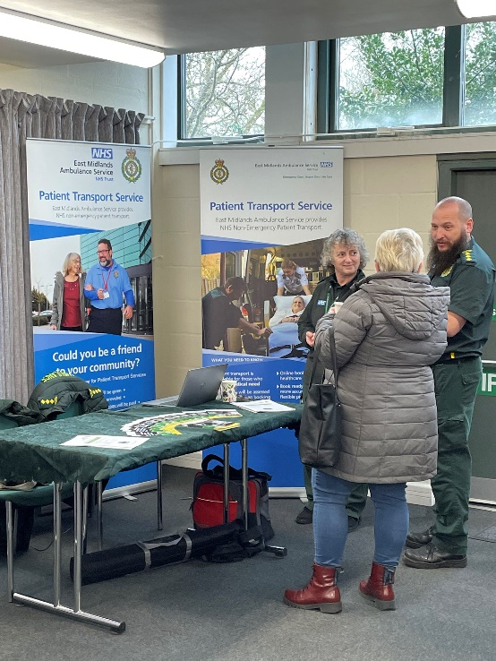
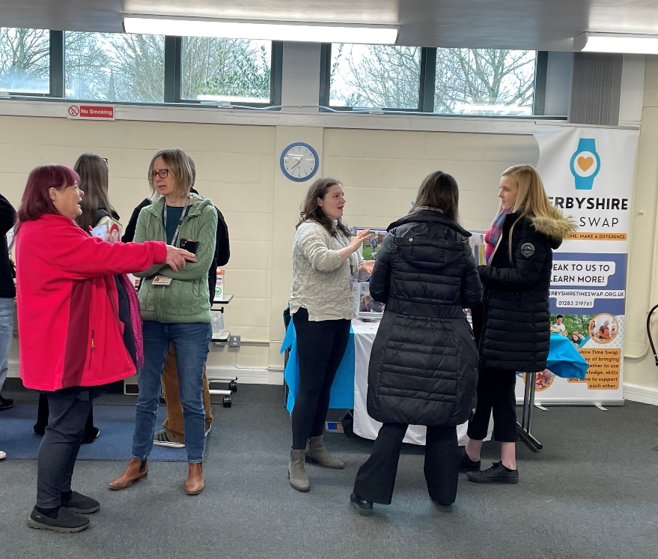

Attendees at the event voted to learn more about different focus of community support:
Active Derbys | III
Alternative Therapies | IIII IIII
Area specific support | IIII
2) Autism & Nueor-diverse support | IIII IIII IIII III
Children &Young People Services | IIII III
Covid impact | II
6) Drug & Alcohol prevention - DRP/DAAS | IIII IIII I
5) Farming Community | IIII IIII II
Funding for VCSE | IIII
Link/Support worker roles | IIII III
5) Living Well Program | IIII IIII II
3) Local Transport | IIII IIII IIII I
4) Mens groups | IIII IIII IIII
1) Mental Health education – Mental Health Disorders, Diagnosis | IIII IIII IIII IIII
Outdoor community projects | IIII IIII II
Shared central Data-base | II
Social events for Dementia Care | IIII
Team Up Derbys | II
Women’s groups | IIII IIII
Refugee & Migrant support | III
Other: Time Swap | I

GAPS identified in Mental Health service provision or community support groups in Derbys Dales:
LOCALITY: | TYPE OF SUPPORT NEEDED: | WHY?
Dales, All Derbyshire, High Peak | ASD/LD | Lack of provision.  Services that do not require a diagnosis to access.
Derbyshire Dales | Youth support  Social Isolation  Carers | Not enough available.  Due to large rural area and just not enough groups/staff t cover it. (What is happening is very good.)  Numbers are reducing.
South Dales | Carers of MH patients, support groups | Lacking – are none in Nor S Dales.
Matlock, Ashbourne, AND all of Derbys Dales | Neuro-diversity Adult  Support groups generally. | Lots of clients requiring support and to meet with others with similar experience/interests.  Lack of support & awareness.  For house bound patients.
All Derbyshire | Transport (and specifically for women and children.) | Lacking community transport.  Accessibility due to Rurality.  Finance.
All Derbyshire Dales | Single Parents  Menopause | Lacking.  Lacking.
High Peak, Derbys Dales | Meet the groups events.  Farming Community | Multiple attendees; MHP - PCN X2, CMHT North Dales, MHP - DHCFT, Tia-Chi-Chuan, Carer, Mental Health Together, Group Development Workers - DD, CVS, Connex, Recovery Worker – DRP, NEPTS – EMAS, Live Life Better Derbyshire, Time-Swap.  Lacking due to rurality.
High Peak | Peer support for Bi-polar disorder.

Specific project work showing improvement in local Mental Health support:
Locality: | Project or Support: | Your role & Organisation:
Darley Dale | Need Farning community support | MHP, PCN – Lime Grove, Imperial Road
Derbyshire Dales, High Peak | Living Well | Service Manager DHCFT  Senior Practitioner Adult Social Care
Chesterfield, High Peak | Action for Children  Young Adult Service | Engagement Worker  Youth Transitional Worker
Derbyshire Dales | Carer Support  Nature Prescriptions  Mental Health support group  Training in Drugs & Alcohol | DCA – Engagement & support.  Delivering information & referring.  PLACE/H&WB  DRPSS
Derby City & County | Living Well | Mental Health Commissioner
Derbys Dales (West County) | Farming Community | ReThink, DRPSS
Matlock, Derbyshire Dales | DRPSS  Game in the park & Craft & Chat | Recovery Worker and Per support worker DRPSS/DFMH.  Facilitator.

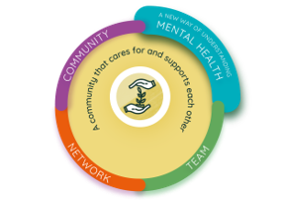
A huge Thank You to All who supported us!
To join the Living Well Collaborative in High Peak or Derbyshire Dales contact Mandy Goodall via email: mandy@highpeakcvs.org.uk

